**INFER**

Team Lead – Divyanshu Shrivastava

**Team –**

|  |  |  |
| --- | --- | --- |
| 1 | Divyanshu Shrivastava | 187909 |
| 2 | Ekta Singh Parmar | 187910 |
| 3 | Ravi Mandoriya | 187928 |
| 4 | Sonali Mandloi | 187936 |
| 5 | Sumit Sisodiya | 187938 |
| 6 | Tanvi Chalisgaonkar | 187943 |
| 7 | Vandita Patel | 187944 |

**Deadstore without error**

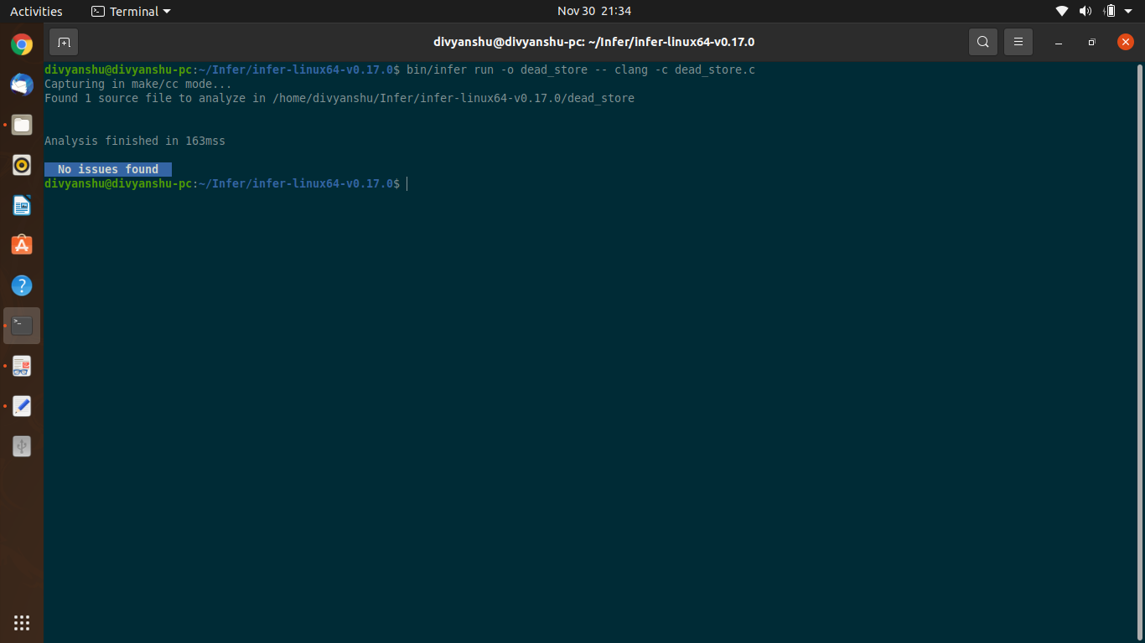

**Deadstore with error**

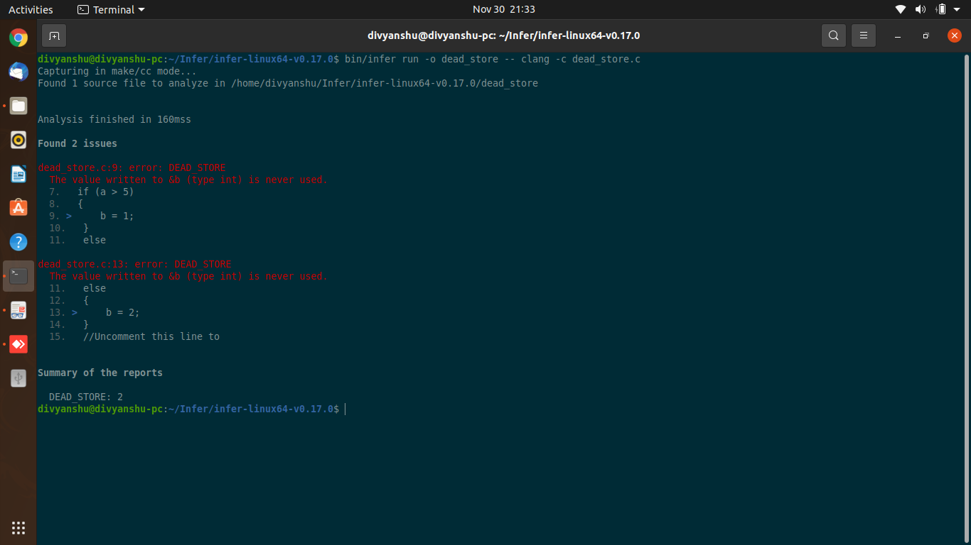

**divbyzero with error**

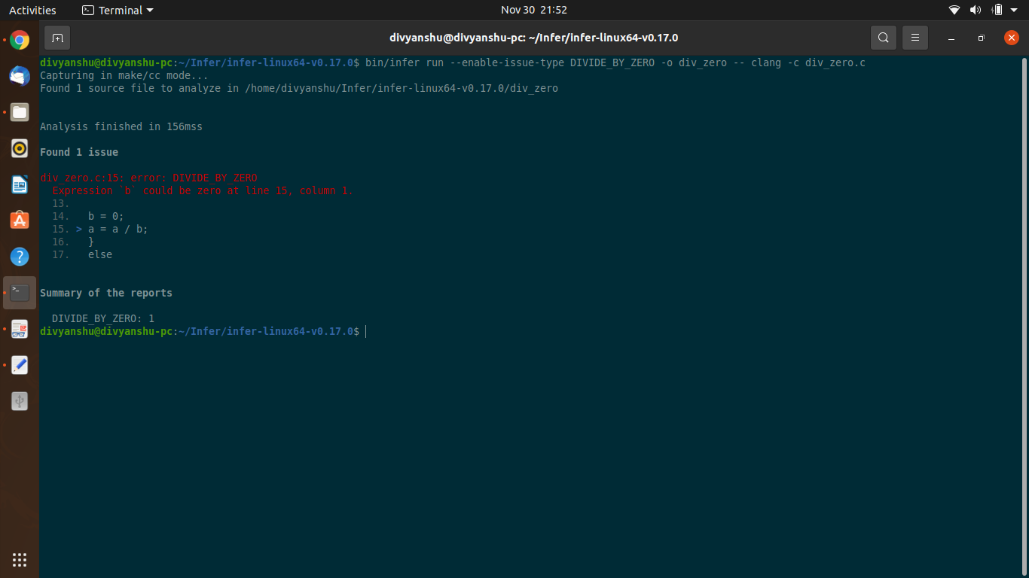

**divbyzero without error**

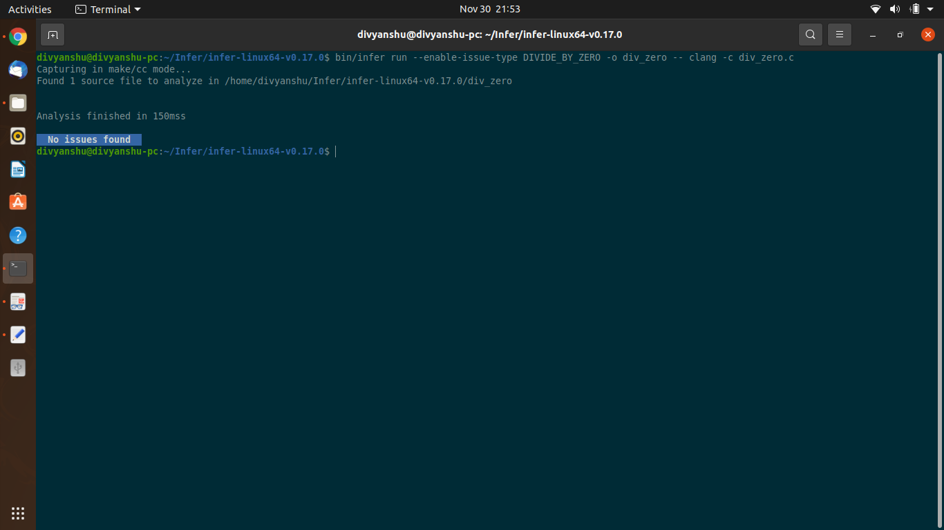

**fixed divbyzero with error**

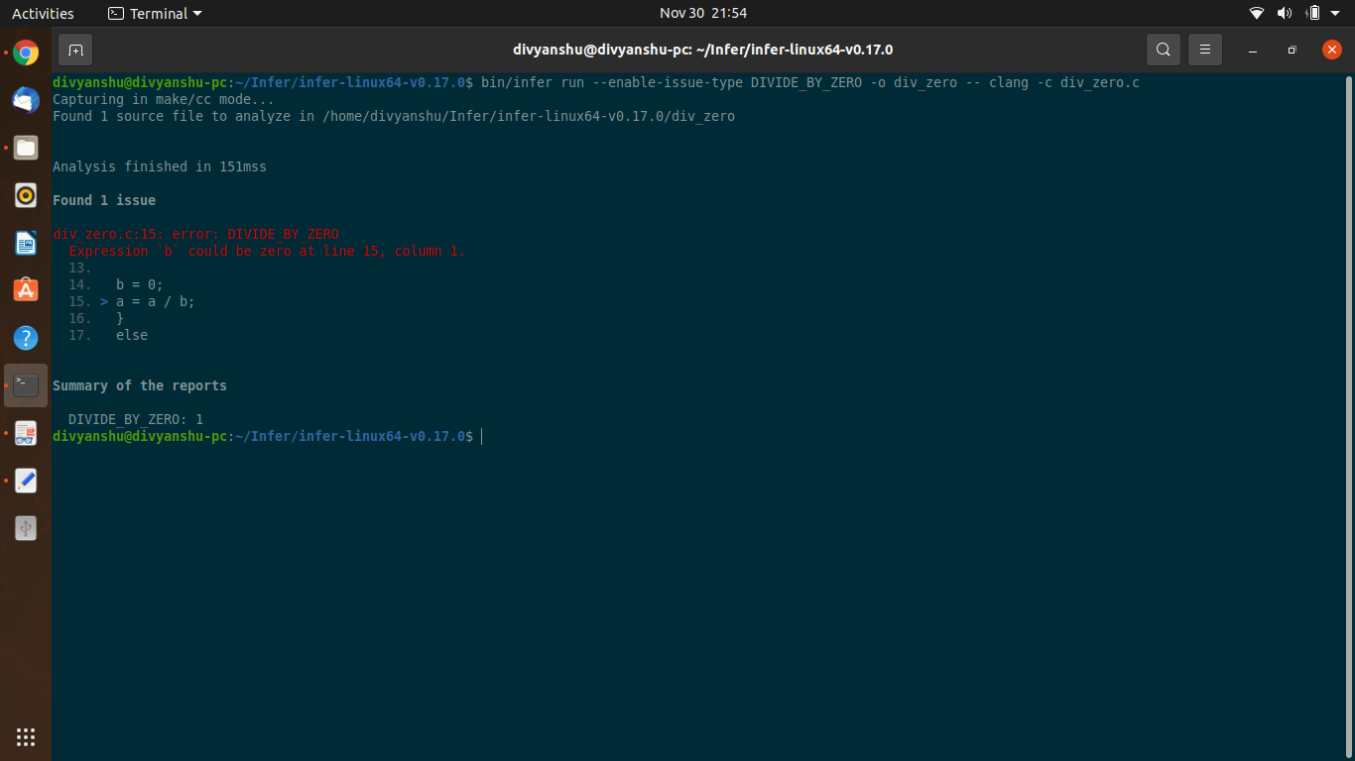

**fixed divbyzero without error**

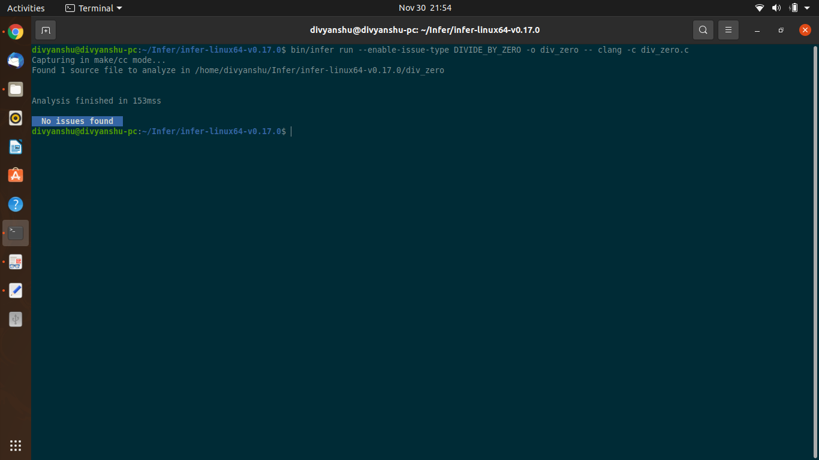

**fixed unintialized with error**

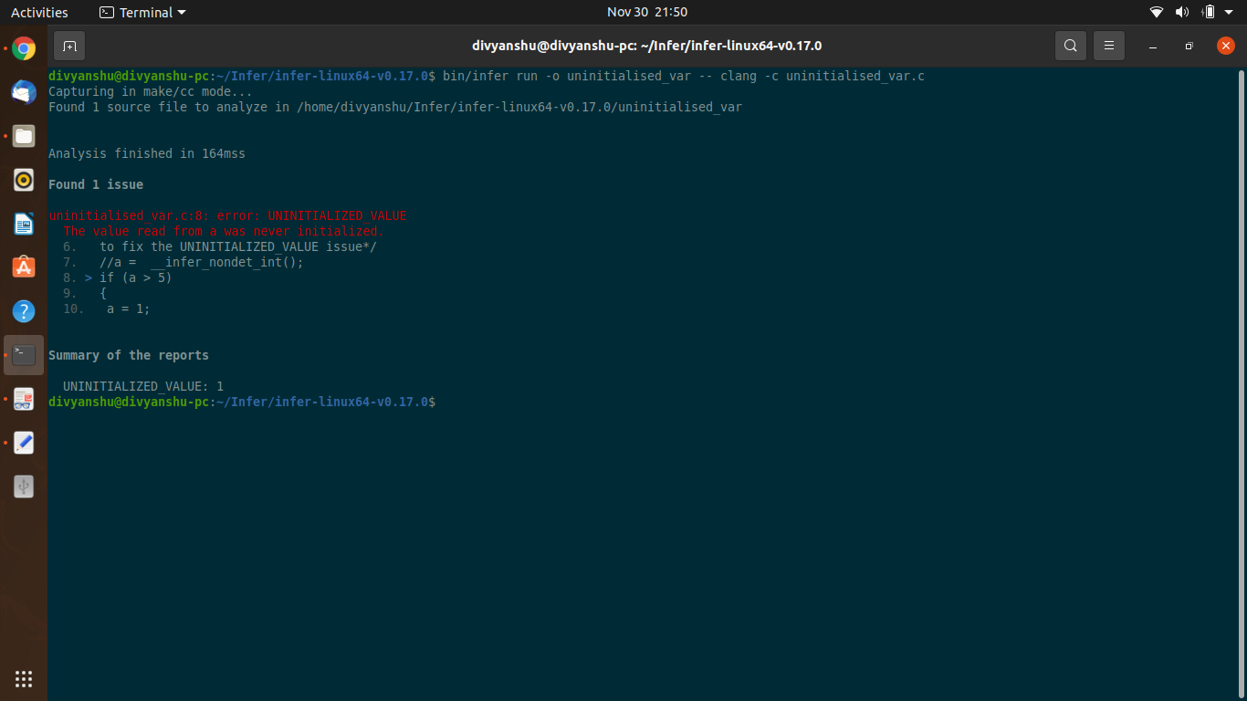

**fixed unintialized without error**

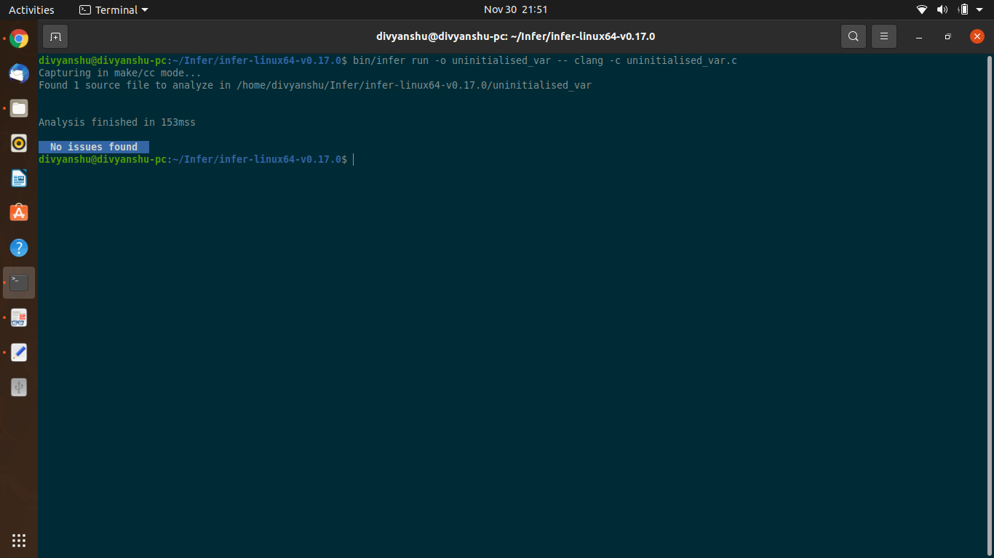

**fixed version with error**

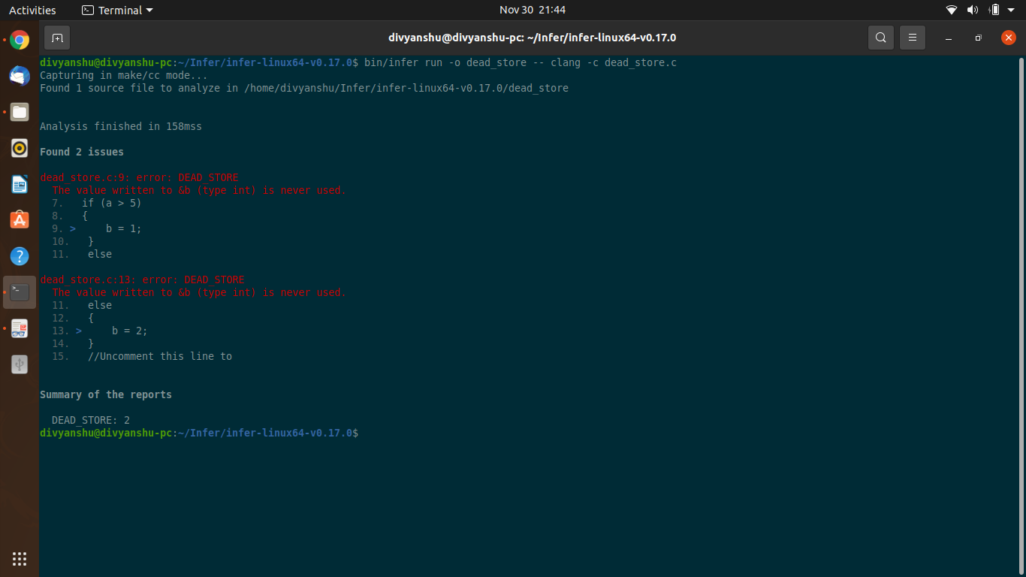

**fixed version without error**

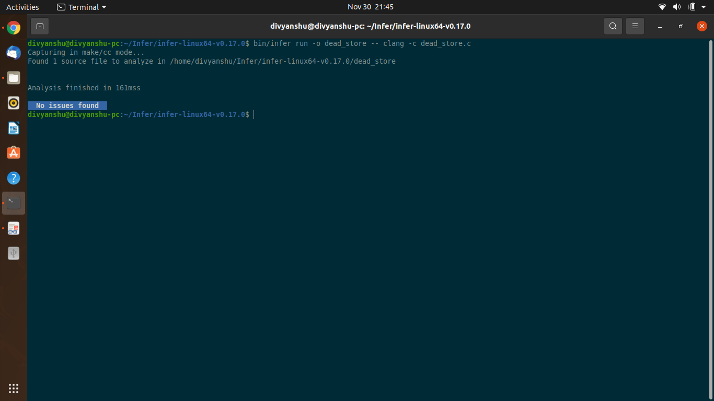

**sample teaching with error**

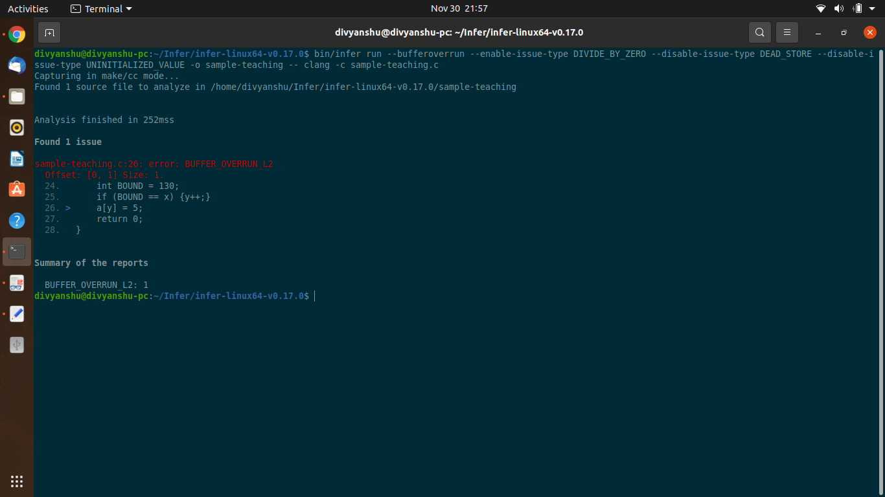

**unintialized with error**

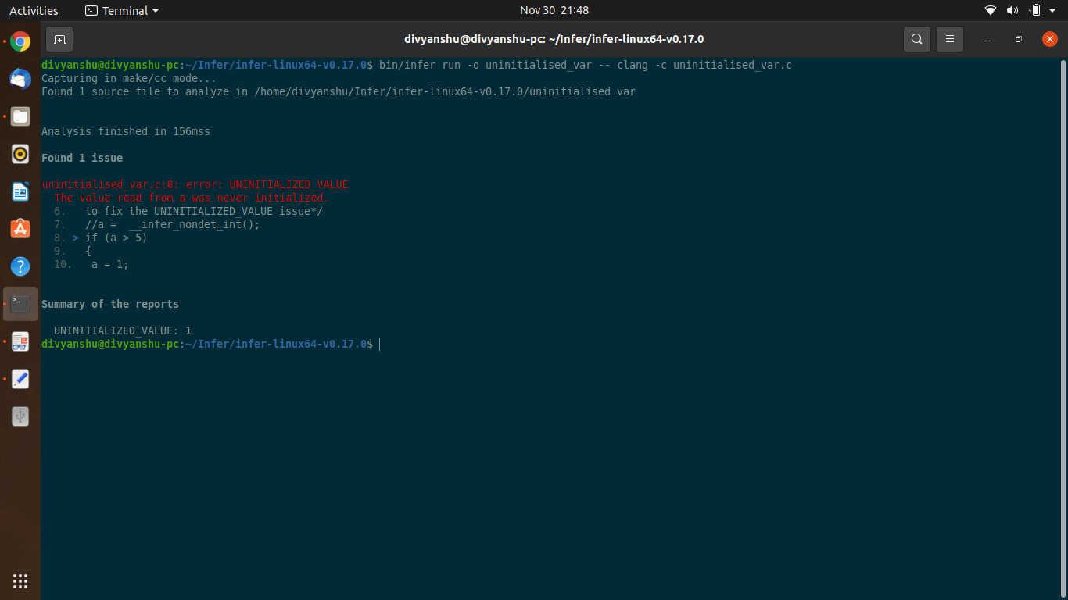

**unintialized without error**

